In this video, we will discuss different types of **ActionResult**objects that can be returned by an action method.   
  
   
  
The following is the signature of a typical action method in a controller. Notice that, the return type is **ActionResult**. ActionResult is an abstract class and has several sub types.  
public ActionResult Index()  
{  
    return View();  
}  
  
   
  
**Here is the list of all sub-types of ActionResult.**  
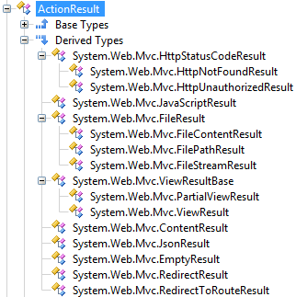   
  
I have used a tool called **ILSpy**, to list all the sub-types of ActionResult. To use the tool yourself, here are the steps  
**1.** Navigate to [http://ilspy.net](http://ilspy.net/)  
**2.** Click on **"Download Binaries"** button, and extract them to a folder.  
**3.** Run ILSpy.exe which can be found in the folder, where you have extracted the binaries.  
**4.** Click on File - Open From GAC  
**5.** Type "System.Web.Mvc" in the search box. Select the Assembly and click Open  
**6.** At this point System.Web.Mvc assmbly should be loaded into ILSpy. Expand System.Web.Mvc, then expand ActionResult and then expand "Derived Types". You should now be able to see all the derived types.  
  
**Why do we have so many sub-types?**  
An action method in a controller, can return a wide range of objects. For example, an action method can return  
**1.** ViewResult  
**2.** PartialViewResult  
**3.** JsonResult  
**4.** RedirectResult etc..  
  
**What should be the return type of an action method - ActionResult or specific derived type?**  
It's a good practise to return specific sub-types, but, if different paths of the action method returns different subtypes, then I would return an ActionResult object. An example is shown below.  
public ActionResult Index()  
{  
    if (Your_Condition)  
        return View();            // returns ViewResult object  
    else  
        return Json("Data");  // returns JsonResult object  
}  
  
**The following table lists**  
**1.** Action Result Sub Types  
**2.** The purpose of each sub-type  
**3.** The helper methods used to retrun the specific sub-type  
